**FAIR SHAKE NETWORK**

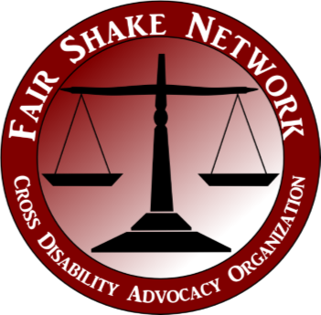

**2023**

**Disability Agenda**

***“Never doubt that a small group of thoughtful, committed people can change the world. Indeed, it is the only thing that ever has.”***

**--Margaret Mead**

**Message from the Chair:** The Fair Shake Network (FSN) has dedicated the last 31 years to serving West Virginians with disabilities and ensuring that they get a “fair shake.” Our mission is to educate policymakers and the public about disability issues and to empower people with disabilities to speak for themselves. Our state has one of the highest populations of disabilities, which means united, our voice is loud. FSN will continue our work so that people with disabilities have an opportunity to equally participate in their communities and realize their dreams. To this end, we will continue to monitor all legislation introduced that may affect the disability community.

FSN urges the Legislature and Executive Branch to invest in people with disabilities and their invaluable resources and contributions to our beautiful state. The relationship between West Virginians with disabilities and policymakers set a high standard for many to look at, demonstrating the power of self-advocacy.

**Please support the 2023 Disability Agenda and continue this legacy.**

**Thank you, Sarah Mathis Jones, Chair**

**Human Rights:**

FSN will advocate for legislation that protects people with disabilities from abuse, neglect, bullying, exploitation, and other rights violations.

**Supported Decision Making:**

FSN will advocate for legislation to establish Supported Decision Making as an alternative to guardianship, and to maximize autonomy for adults with disabilities by permitting the choice of a supporter to assist them with making their own decisions about their life.

**Home and Community Based Services and**

**Supports:**

FSN will advocate for Home and Community Based Services and other services to bring WV into compliance with the Americans with Disabilities Act (ADA).

FSN **will not** support the development of segregated/congregate service settings.

**Independent Living Services:**

FSN will Advocate to expand the network of Centers for Independent Living (CILs) statewide to ensure every West Virginian with a disability has access to the services and resources provided by a CIL.

**Housing:**

Advocate for housing legislation that increases the statewide availability of accessible, economical, integrated, and safe community-based housing. We will support any legislation that supports universal design in home construction.

**Other Issues:**

FSN will monitor all legislation introduced that may affect people with disabilities such as:

• Civil Commitment Process

• Sub Minimum Wages

• Transportation

• Elimination of Out-of-State Placemen

• Education

• Out-Of-State Placement

**Funding Issues:**

FSN supports increases in funding necessary to maintain or enhance critical support services that allow people with disabilities to live, work, and engage in recreation in the community.

• All Medicaid Waiver Programs

• Birth-to-Three-Program

• Division of Rehabilitation Services Employment Attendant Care Program

• Extended Supported Employment Services

• Family Support

• Long-term and Services and Supports

• Medicaid Expansion Program

• Ron Yost Personal Assistance Services Program (RYPAS)

• Independent Living Services (CLSP)

For More Information, Contact:

Paul Smith, Director

Fair Shake Network

P.O. Box 354

Institute, WV 25112

E-Mail: FSN@fairshake.org

Phone: 304-766-0061 or 1-800-497-4746

Visit us on our Website: [www.fairshake.org](http://www.fairshake.org)